Write a program to implement different exception handling methods in java

public class Exception {

public static void main(String args[])

{

try{

try{

int array[]={1,2,3};

System.out.println("the number is" +array[1]);

}

catch(ArrayIndexOutOfBoundsException e)

{

System.out.println("Out of bounds ");

}

System.out.print(8/0);

}

catch(ArithmeticException e)

{

System.out.println("Cant divide by zero");

}

}

}

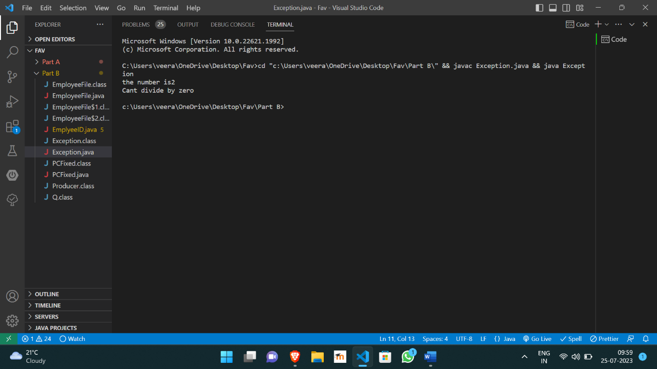

https://github.com/Veeragoutham04/Java_Lab/blob/main/Exception%20handling